Node lets us write server code in javascript

**SECTION 2: V8 THE JAVASCRIPT ENGINE**

V8 JS engine (the heart of node.js)

You have a processor which is given instructions in machine code (programming language spoken by a computer processor)

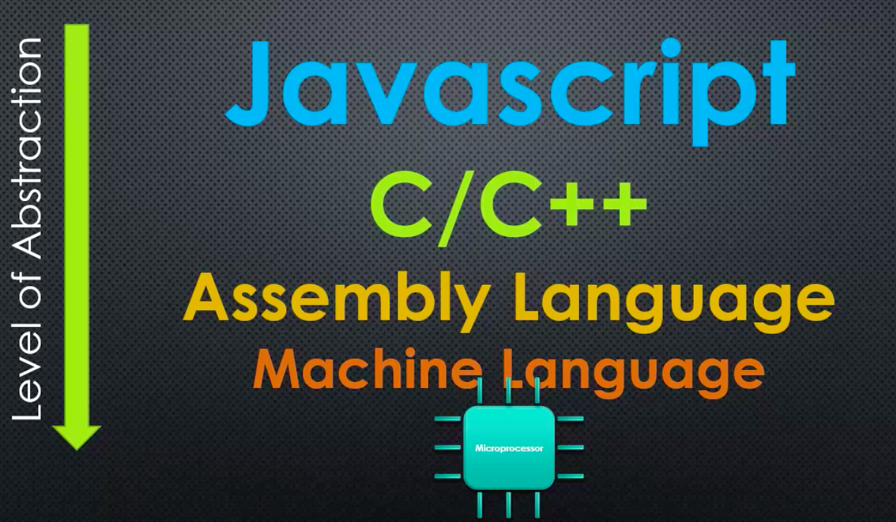

everything written is JS is compiled through an engine that takes care of memory access and stuff, so the processor understands it

Node is written in C++!

* Because V8 (the JS engine that converts JS into machine code) is written in C++
* Node JS is built on top of V8

JAVASCRIPT ENGINES AND ECMASCRIPT SPECIFICATION

ECMASCRIPT

* The standard javascript is based on (many browsers appeared with their own engines, so a standard for JS was needed) (tells how the language should work)
* V8 makes sure the machine code that JS is compiled to works as the specification in ECMASCRIPT says

JS engine

* A program that converts JS code into machine code; in the case of V8, it should follow the ECMAscript standard

V8 is a JS engine, and it sits at the core of Node JS (node is built on top of it)

ADDING FEATURES TO JAVASCRIPT

You can embed the V8 engine into your c++ programs (since V8 is written in c++)

* In this way, you can make V8 do more things than V8 can actually do

I can write things in c++, that JS does not have, and make everything that I can do with c++ available to JS code

* JS was built for the browser, c++ was built for more lower level

You can add features to JS using c++ and extending the functionality of V8

* You send JS code to your c++ program, which then sends it to V8, then V8 calls the c++ code appropiatly for the JS code
* What you do is you tell V8 that when it encounters a certain word in JS code, V8 needs to call a specified function in c++ (which JS does not support for alone)
* This adds functionality to JS code

So V8 is built to be embedded to c++ programs so that c++ functionality is available to JS code (c++ functionality gets called through JS)

Google chrome is built in c++, it embeds V8. So when you make any kind of DOM manipulation using JS in your websites; this feature is actually not specified in the ECMAscript, it has been added by the google chrome browser. So it is adding functionality to JS.

Node JS is a c++ program, with V8 embedded that has added a bunch of c++ features in order to be a server technology

**SECTION 3: THE NODE CORE**

SERVERS AND CLIENTS

Node JS was designed to use JS to write server code

Front-end web development

* Coding in the browser

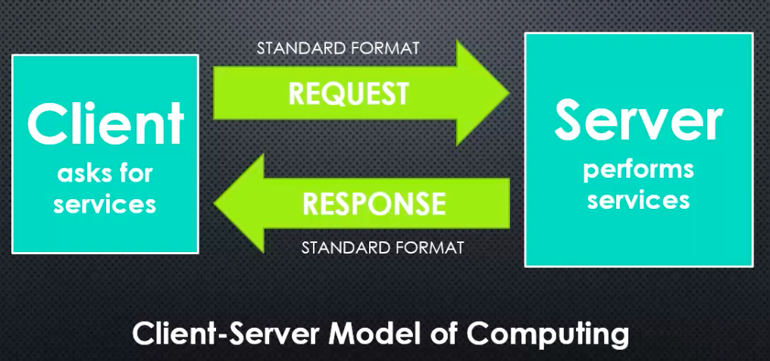

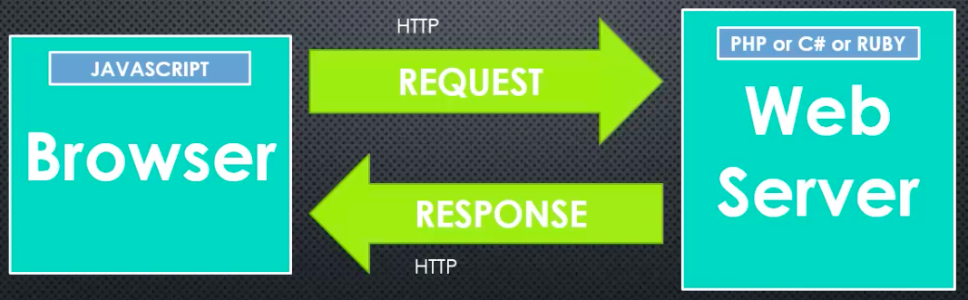

when doing some coding in the client side, you would use JS, but when doing some coding in the server side, you had to switch to another programming language such as PHP, etc.

Therefore, NodeJS goal is to write JS on the webserver, so you don’t need to switch between programming languages; you just need to use JS.

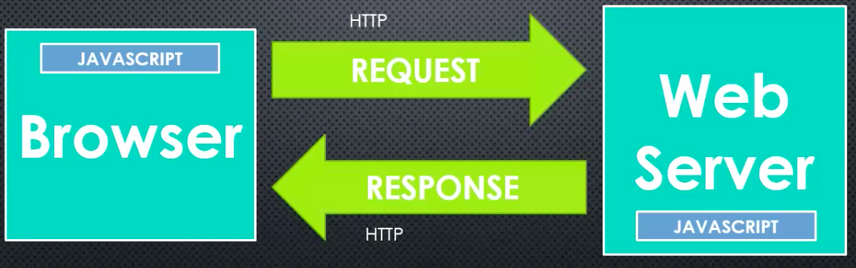

WHAT DOES JS NEED TO MANAGE A SERVER

1. Better ways to organize our code into reusable pieces
2. Ways to deal with files
3. Ways to deal with databases
4. The ability to communicate over the internet
5. The ability to accept requests and send responses (in the standard format)
6. A way to deal with work that takes a long time

NodeJS takes care of all of these requirements

THE C++ CORE

deps folder

* Things that were built outside of NodeJS, but that are part of NodeJS

src folder

* The c++ source code

NodeJS is not javascript; NodeJS accepts Javascript; but at the same time and allows us to have more features when using JS

THE JAVASCRIPT CORE

lib folder

* The JS source code
* The most part are wrappers, they are JS libraries that wrap c++ features

**SECTION 4: MODULES, EXPORTS, AND REQUIRES**

Module

* A reusable block of code whose existence does not accidentally impact other code
* It is independent from the other code, but works with it
* You can re-use it
* A way to structure your code; to organize it as it grows

Common JS modules

* An agreed upon standard for how code modules should be structured

First class functions

* Everything you can do with other types, you can do with functions
* You can use functions like strings, numbers, pass them around, set variables equal to them, put them in arrays, etc.
* Allow us to write function expressions on the fly

LET’S BUILD A MODULE

Modules are independent, they do not affect code in other files, so when you specify a “require” in a file, and specify the path for another file; this will not give you access to the variables and functions of the file you are requiring, hence it does not intervene with your code. What this will do is that any code that is supposed to run in the file that is being required, will run.

* So, you can have variables and functions with the same name in each file, this does not matter, since modules do not affect the code in other files

To make the variables and functions of a JS file available to other files, then we need to specify a “module.exports = …”, and selecting the things that we want to make publicly available.

* This will make vars and funcs available to use, outside of the module

The “require” and “module.exports” functions are inside the JS core of the nodeJS code

OBJECTS AND OBJECT LITERALS

Object in JS

* A collection of name/value pairs

Object literal

* Name/value pairs separated by commas and surrounded by curly braces
* Is a quick way of creating JS objects

PROTOTYPAL INHERITANCE AND FUNCTION CONSTRUCTORS

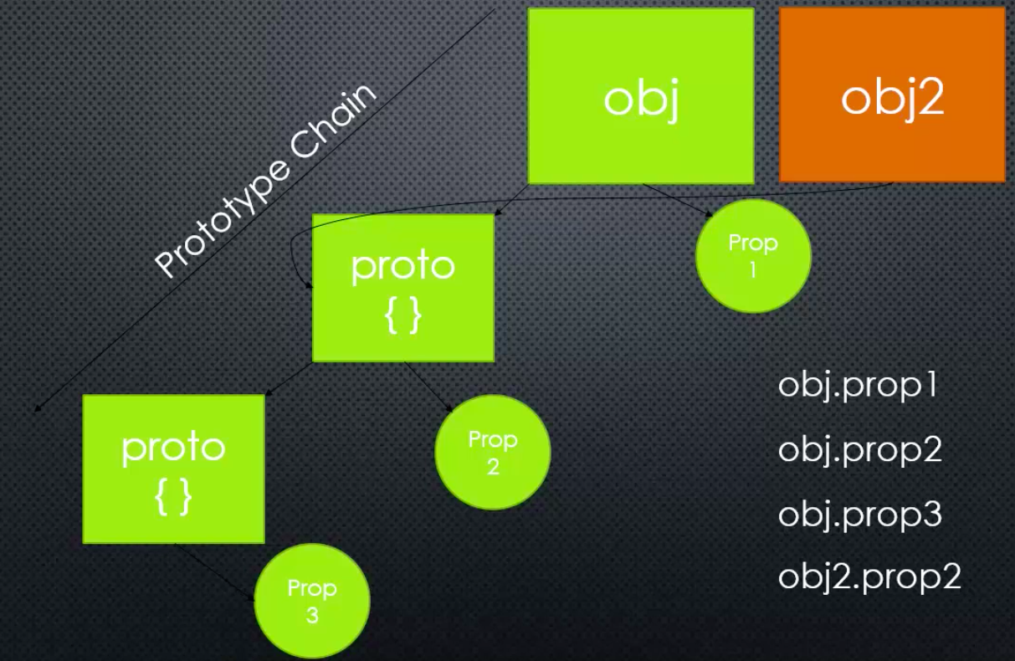

functions are also objects, so you can have properties and methods inside a function as well; just as a regular object does.

In JS, objects inherit from other objects.

Is more common in JS for objects to inherit from prototypes than from classes (as in c++); so all you do is just add properties and methods to the prototype property of the function constructor for the object. This way all objects created from that function constructor will inherit the properties and methods of the prototype

Every object has a property that points to another object; it is the object’s prototype. It is the thing it inherits from. This prototype can have other properties and methods. Moreover, the prototype has also a property that points to another object; it is the prototype’s prototype and so on. This forms the prototype chain. This is how JS implements the idea of inheritance.

Function constructor

* A normal function that is used to construct objects
* The “this” variable points to a new empty object, which is returned from the function

.property function

* We are adding some methods/properties to be available to all objects created from a function constructor

BY REFERENCE AND BY VALUE

Primitive

* A type of data that represents a single value (not an object)

Objects are always passed by reference

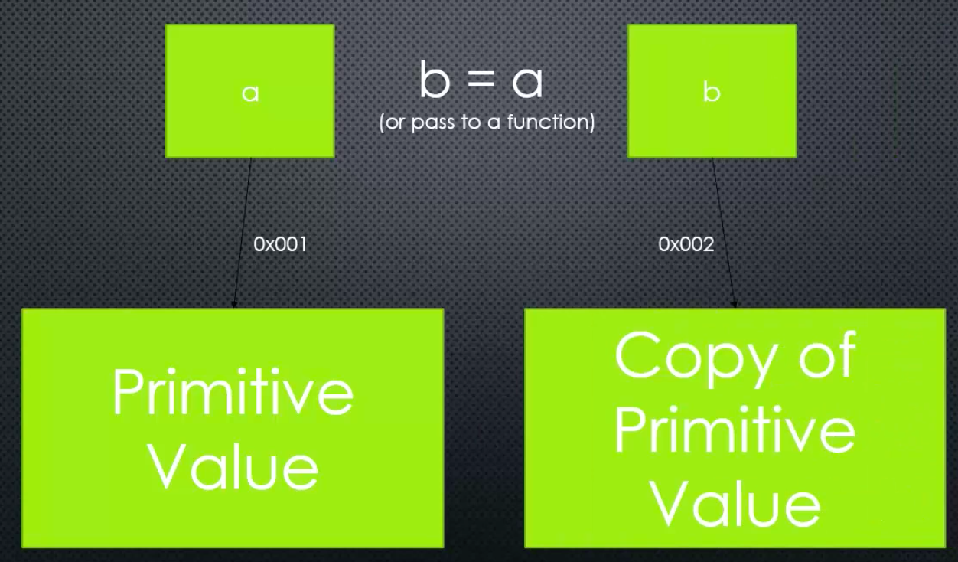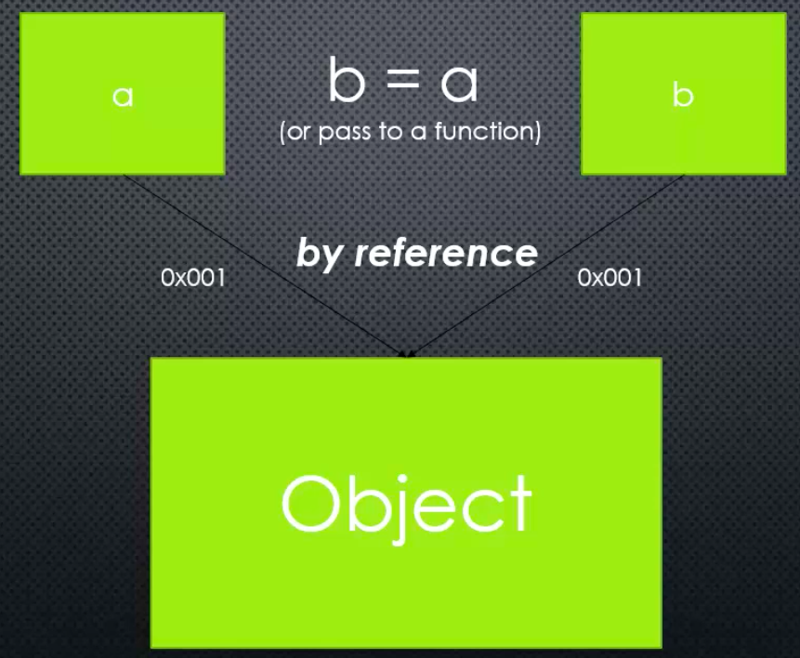

IMMEDIATELY INVOKED FUNCTIONS

The scope of the variables sits within the IIFE, you can have two variables with the same name in a file as long as one of them sits inside an IIFE

* IIFE’s therefore behave somewhat similar as modules, their code does not affect other code; IIFE’s wrap code inside

HOW DO NODE MODULES REALLY WORK? MODULE.EXPORTS AND REQUIRE

Your JS code get passed to node, which in turn wraps it inside a function expression, then your code runs, and module.exports is returned

The keyword require returns an object, which references the value of module.exports for a given file

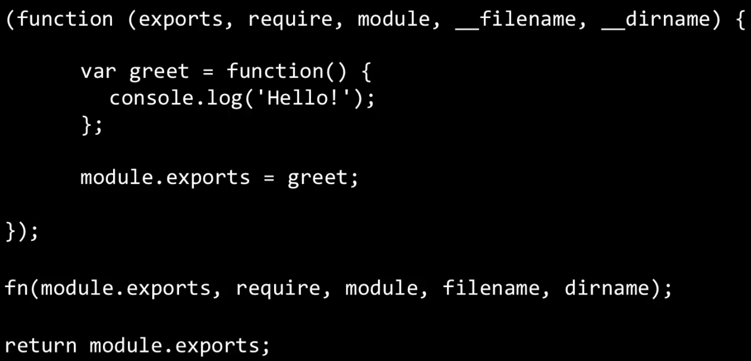

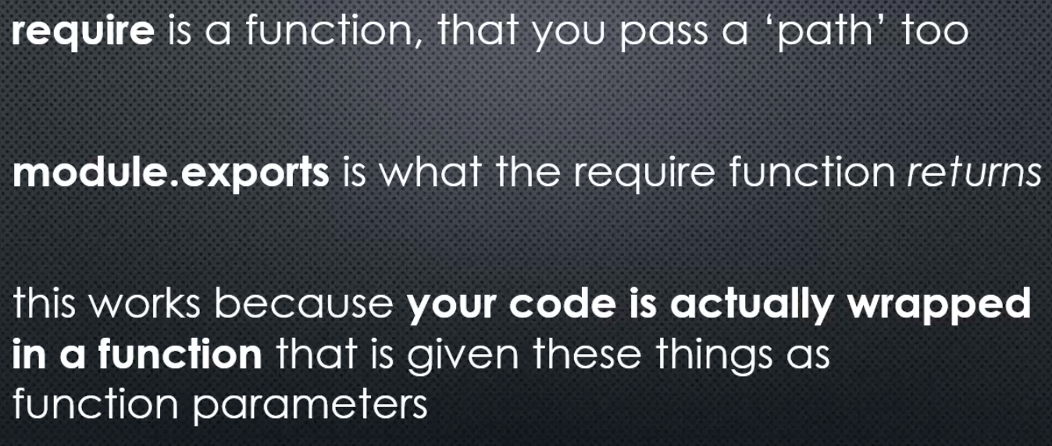

JSONS

Standard for structuring data that is inspired by JS object literals

* JS engines are built to understand it; they can convert JS objects into JSON and JSON into JS objects
* In a .JSON file, you don’t need to specify a module.exports, when the require function is made, the engine will convert the JSON text into JS code

MODULE PATTERNS

“require” caches the results of the require function for any particular filename

* If you simply return an object from “require”, that will be cached, and any other call to that same file via the require function will get you back the same object everywhere

the revealing module pattern

* Exposing only the properties and methods you want via a returned object

EXPORTS VS MODULE.EXPORTS

When our code gets run in node, it gets wrapped inside a function expression

* When this function expression runs, module.exports is passed to the variable “exports” and both point to the same object (same space in memory)

Module.exports is what is passed to exports; they point at the same memory location

* Yet, the property exports of the object “module” is a different variable than the variable “exports” that is passed as a parameter. However, both variables point to the same object



so, if exports is just a shorthand of module.exports, why not use exports instead all the time?

* There is a problem in JS when it comes to objects passed as reference

In JS, when a variable is set equal to a value, then it is assigned a new memory location

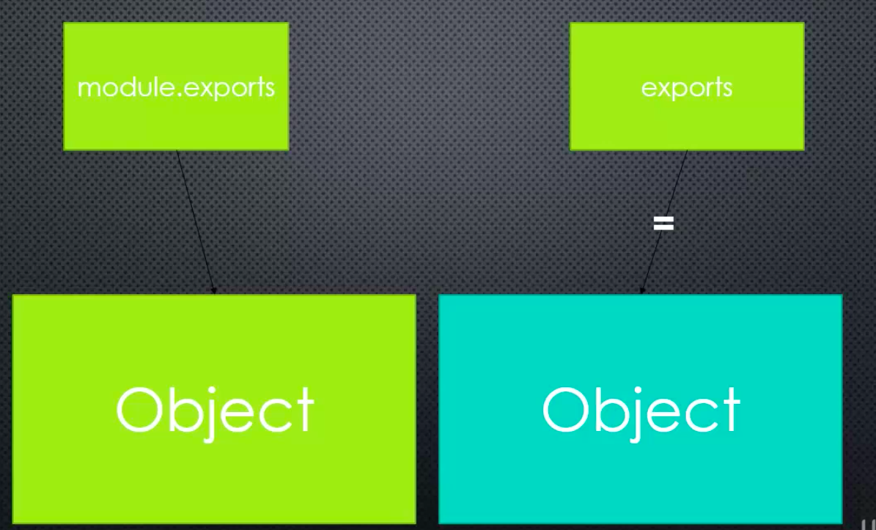

when it comes to using “exports”, you can’t overwrite it, you can’t use “=”

* However, you can add properties or methods

Tip!

* Just use module.exports

REQUIRING NATIVE (CORE) MODULES

The return function asks if wha you ask for is a native module, if it is then that’s what get returned

Native module

* The JS core of nodeJS; code that is already available to me
* The files inside the lib folder
* Check the API documentation to see what each file does

Some native modules are global and others are not, you need to use the require for native modules that are not global

MODULES AND ES6

nodeJS was the one who introduced modules to JS, but with ES6, modules now are prebuilt (available) in JS as default

if you see the following code, then it is JS modules. If you see “require” and “module.exports” then it is node modules.

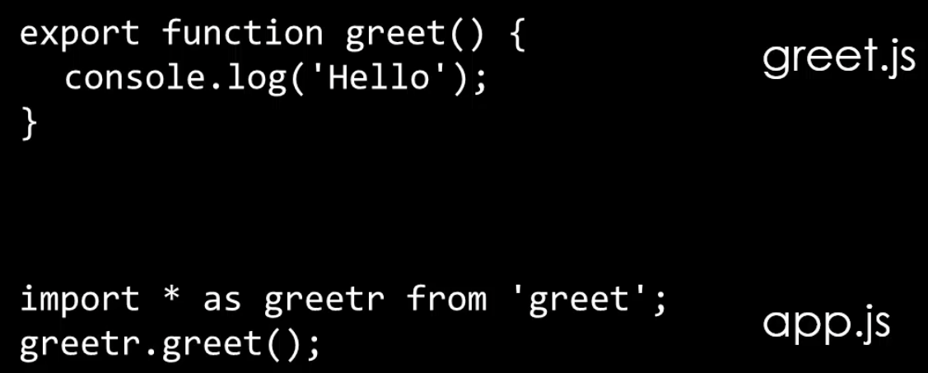

Tip!

* Just use JS ES6 modules; with export and import

WEB SERVER CHECKLIST

JS needed more functionality in order to be a server language, this is what node has brought to the table, a lot of c++ functionality through V8

The following is what JS needed in order to be a server language

* The first bullet is already taken care by node by providing modules! Using “require” and “module.exports”

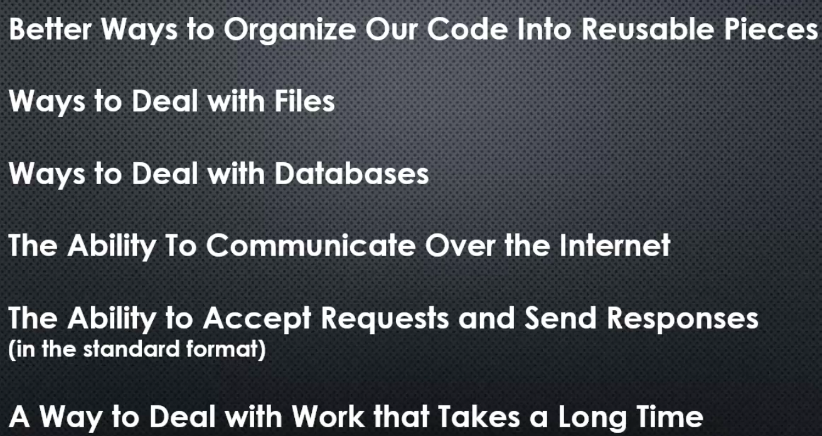

* JS modules are easier to handle because they are integrated into JS by default, there is no need to give that code to node, so it wraps our code into a function expression, and then return what is inside the module.exports.
* If it is already integrated into JS, use it.

**SECTION 5: EVENTS AND THE EVENT EMITTER**

Event

* Something that has happened in our app that we can respond to; there are two types of events in node
* System events = lower level events (finished reading a file, etc), part of c++
* Custom events = we can create our own event library using the technique of system events

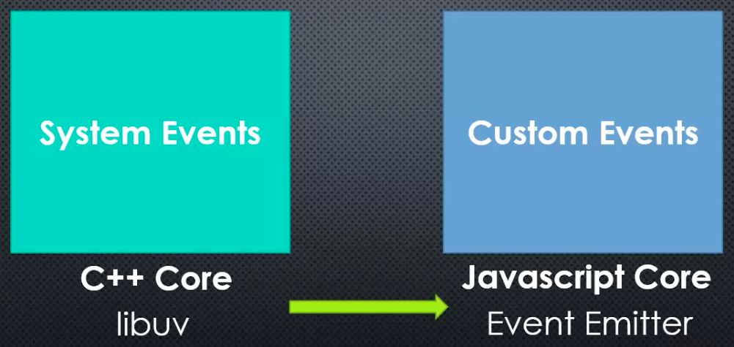

EVENTS AND THE EVENT EMITTER

concepts to understand the event emitter

1. You can use a variable to dynamically grab a value off a property or method in an object
2. You can put functions inside arrays and loop through the array, calling each function

THE NODE EVENT EMITTER PART 1

Here we build our own custom JS event emitter

Event listener

* The code that responds to an event
* In JS, it is a function
* You can have many listeners, listening for the same event; and when the event happens, the functions execute one at a time

To emit an event means to inform that an event happened

The event emitter allows us to avoid having to write a lot of if, then… for every possible function belonging to a partivular event. Instead, you can just listen for an event and then loop through an array of functions

An even emitter is just an object with properties (that represent events), which are arrays, filled with functions or also called event listeners, ready to execute when the event occurs

THE NODE EVENT EMITTER PART 2

Type

* Property name of the object

Listener

* Function inside the array (property)

There is one problem with the event emitter = it relies on magic strings

* Magic strings = a string that has some special meaning in our code
* Relying on magic strings is bad because it makes it easy for a typo to cause a bug, and hard for tools to help us find it
* This is what our event emitter is, when we pass as an argument a string (which represents an event), which is the property of an object. This string needs to be correctly typed so that our code works properly.
* So, relying the logic on your program on strings can be problematic

Solution to magic strings

passing strings in the form of variables, so if we make a typo, it is easier for the debugger to find the error

OBJECT.CREATE AND PROTOTYPE

There are a number of ways to set up the prototype chain. One of them we already used = adding methods and properties to the prototype of the function constructor. This will tell the object what it will inherit.

1. Function constructors
2. ES6 classes with keyword “extends”
3. Object.create()

INHERITING FROM THE EVENT EMITTER

There are a lot of JS core modules that do the following technique:

There is a method called “.inherits” which takes two parameters

1. ctor = A function constructor upon which you want to add new methods and properties to be available to objects created with it
2. superCtor = A function constructor where that’s where the properties and methods you want to be added on to your objects are sitting

The methods and properties of the prototype property of the superCtor function constructor will become available the prototype chain from objects created with ctor function constructor

You can create objects that have a combination of functionality of one object and another object

* you can have objects that do many things plus behaves as an eventEmitter (listens and emits events)
* many objects in node development allow you to listen to and emit events because they have the eventEmitter down their prototype chain. So these objects are a type of eventEmitters

NODE, ES6, AND TEMPLATE LITERALS

ES6 = ECMAscript 2015

babeljs.io

* receives ES6 JS code and converts it into ES5 syntax

template literal

* a way to concatenate strings in ES6
* you don’t have a bunch of strings concatenated with “+”
* you use back ticks `` and ${ } to write a string or an expression or anything

in node you can fully implement ES6 features because node has the latest version of V8 embedded, but you can't fully implement ES6 features in the browser because the user may not have the latest browser version downloaded, hence will not have the latest V8 version in it; but you can use tools like babel to get around this issue.

.CALL AND .APPLY

they are useful for borrowing methods, and passing them the object we want to work on

using .call() is the same as invoking the function, the difference is that you can pass a variable to it, and whatever you pass, is what the "this" keyword will point to.

the only difference between .call and .apply is how you pass parameters to a function. With .call you separate parameters by commas, but with .apply you use an array to pass them.

INHERITING FROM THE EVENT EMITTER 2

The previous part of inheriting from the event emitter we made an incomplete inheritance, because what happens if the eventEmitter were also to add properties directly to the object being created and not to its prototype. We were ignoring these properties and methods with our previous example.

EventEmitter.call(this)

* this one line of code ensures that my object created from a function constructor has everything an object created from eventEmitter would have

ES6 CLASSES

A new way to build objects, from a syntax standpoint. It is called syntactic sugar

It is called syntactic sugar

* a feature that only changes how you type something, butnothing changes under the hood

Require returns module.exports

Un callback es una función que se llama de manera asynchrona y se utiliza como parámetro en otra función

Un event handler es un callback asociado a un evento, tiene un event handler (que es el callback)

When you execute something synchronously, you wait for it to finish before moving on to another task. When you execute something asynchronously, you can move on to another task before it finishes.